**Software Design Document, Testing, Deployment, Configuration Management And User Manual**

* **Description:** Work Fusion enables enterprises to automate high-volume, manually intensive business processes through a combination of robotic process automation (RPA) and cognitive automation, powered by machine learning. Work Fusion is a desktop application. RPA Express is a free software product that lets you automate web, desktop, and terminal applications so that you can do bigger things. Here we are using this tool to automate our staging and exporting process. Work fusion is all about writing scripts.
* **Prerequisties:**

1. Make sure your computer meets [System Requirements](https://kb.workfusion.com/display/RPAe/System+Requirements).

2) Stop your running programs.

3) Check if automatic Windows updates are not running at the moment.

4) Run the installer as Administrator.

5) In case installation includes a [Server](https://kb.workfusion.com/display/RPAe/RPA+Express+Installation#RPAExpressInstallation-Types) package, make sure you open

ports 15100, 15110, 15280 for external usage inside your network (if

you plan to use it on other computers).

Make sure that ports 15410-15423, 15444, 15580, 15306 are closed to

any external interaction.

* **Selecting Licensing Model**

1. **RPA Express Starter** is a completely free product for individual use only, with no trial period, no license generated, and less [system requirements](https://kb.workfusion.com/display/RPAe/System+Requirements). Within the licensing model, Work Fusion Studio is installed, OCR and RPA components are provided.
2. **RPA Express Pro Business** includes the whole set of server components together with Work Fusion Studio, thus enabling you to automate complex use cases, manage multiple bots, and run automation unattended at scale.

* **In our automation projects we have used RPA Express Starter which is absolutely free.**
* **System-Requirements:**

|  |  |  |  |  |  |
| --- | --- | --- | --- | --- | --- |
| **Type** | **OS** | **OS Type** | **CPU** | **RAM** | **Disk Space** |
| **Development Workstation and Server**([Free + Premium features](https://kb.workfusion.com/display/RPAe/RPA+Express+Installation#RPAExpressInstallation-Business)) | **Windows: 7, 8, 8.1, 10**  OR  **Windows Server**: 2012, 2012 R2, 2016 | 64 bit | 4 cores at 2.8 GHz | Minimum 8 GB of free memory  (16 GB recommended) | 8.5 GB |
| **Development Workstation** ([Free](https://kb.workfusion.com/display/RPAe/RPA+Express+Installation#RPAExpressInstallation-Starter)) | **Windows**: 7, 8, 8.1, 10  OR  **Windows Server**: 2012, 2012 R2, 2016 | 2 cores at 2.8 GHz | Minimum 4 GB of free memory  (8 GB recommended) | 5.3 GB |

* We have used windows 10 as our operating system to develop the automation projects.
* **RPA Express Download:**

To download RPA Express, follow the instructions below.

1. Open the [Work Fusion website](https://www.workfusion.com/).

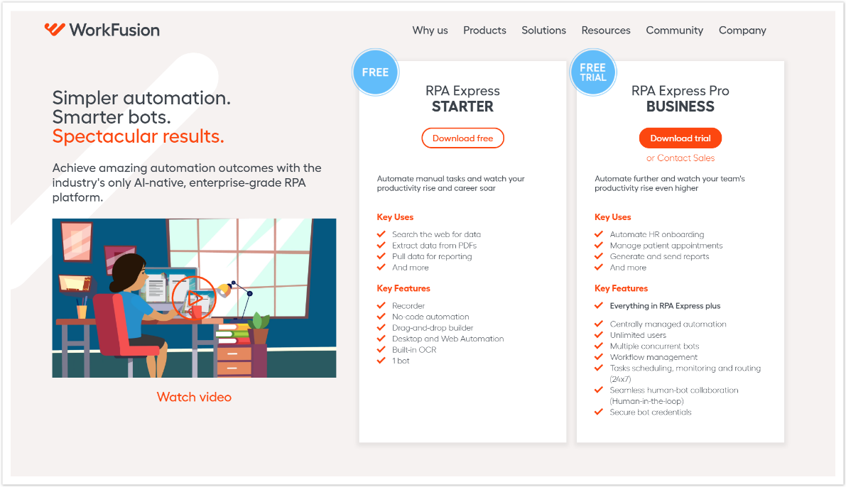

****2. Click **Get free RPA** in the top-right corner,or select **Products > Robotic Process Automation Express – RPA Express**

1. Select your licensing-model  and, depending on your choice, click **Download-free**.

1. 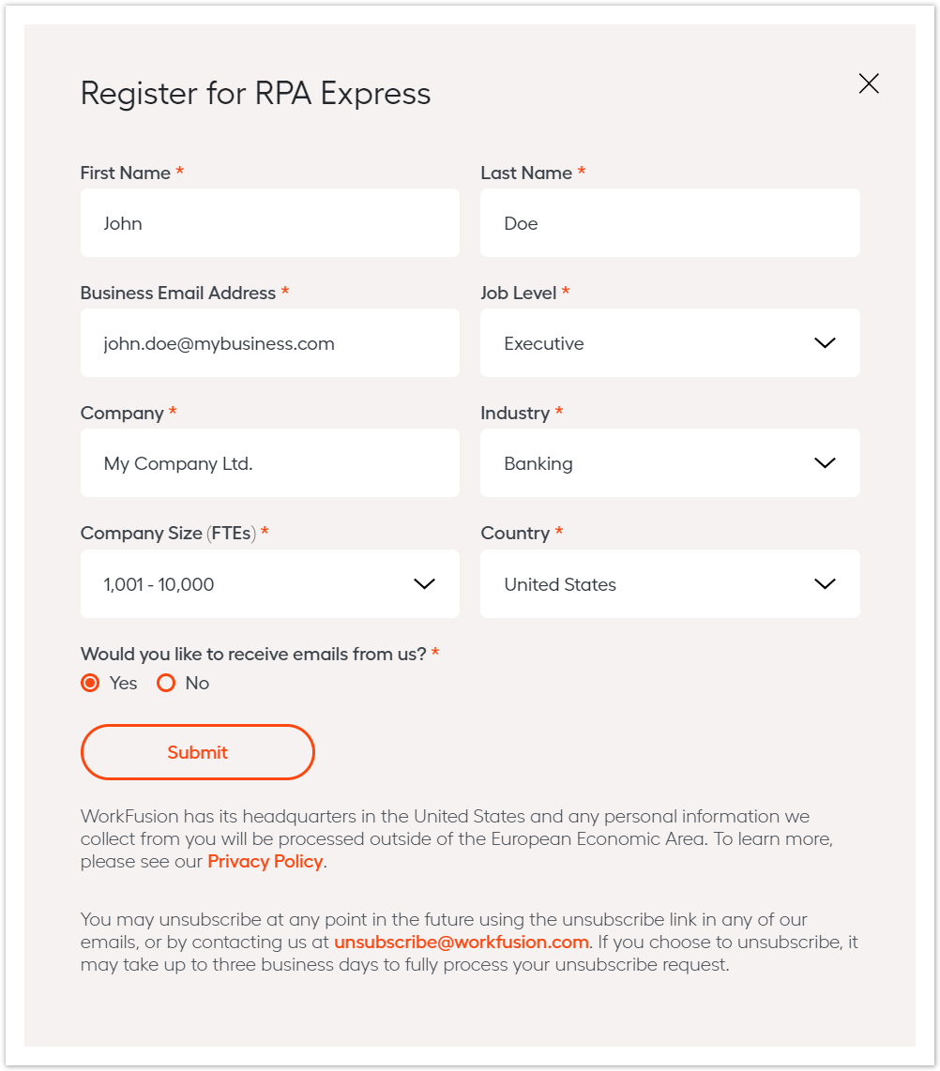Fill in the registration form and click **Submit**.
2. You will see **End User License Agreement and the Subscription Order**. To continue, press **Accept and Download**.

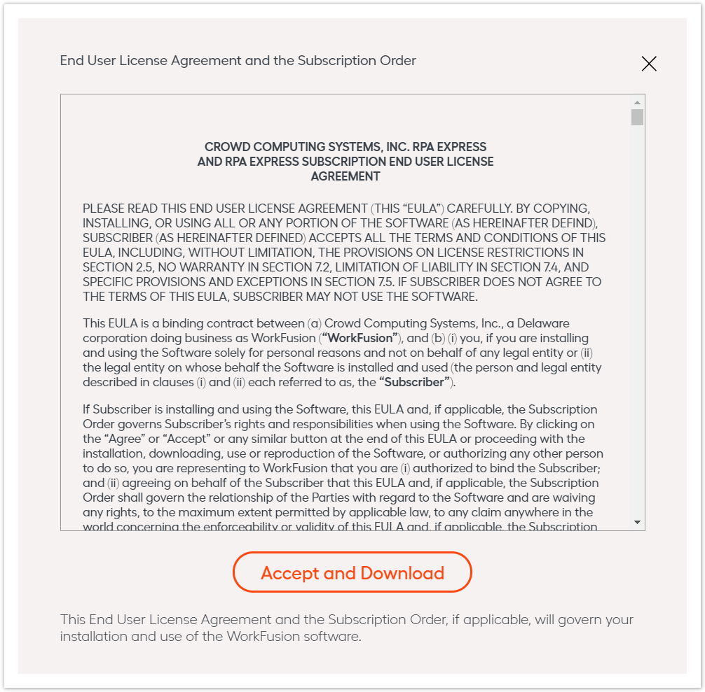

6. You are automatically redirected to the download page, and the installer

file (**18 MB**) is downloaded automatically.

* **RPA Express Installation:**

Depending on what licensing model you have selected, the installation

procedure varies. At the moment, there are two installation options. We

are using RPA-Express Starter in our project.

**RPA Express Starter** refers to a completely free product, with no trial

period, no license generated.

To install RPA Express, follow the steps below.

1. Run **FreeRPAExpressInstaller.exe**

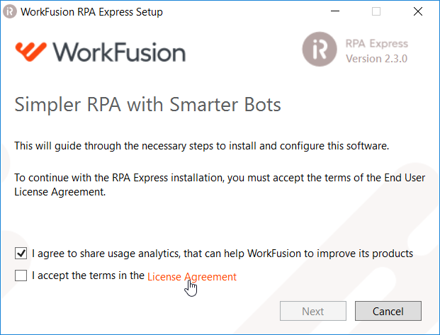2.To start installation process, you must accept the License Agreement. Click **License Agreement** to view it.

1. 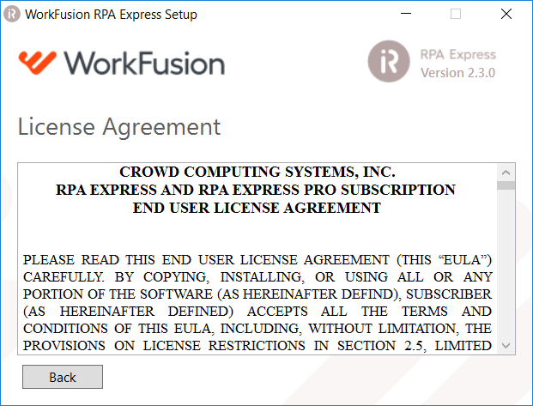Read the License Agreement carefully. Use the scroll bar or press the page-down-key.
2. To accept, check **I accept the terms in the License Agreement** and press **Next**.

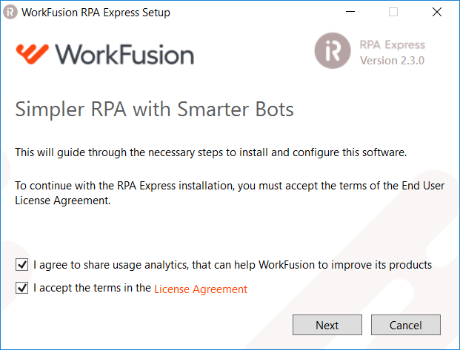

5.Enter the email you used when [registering](https://kb.workfusion.com/pages/viewpage.action?pageId=42568504#RPAExpressInstallation-Registrationform) for RPA Express.

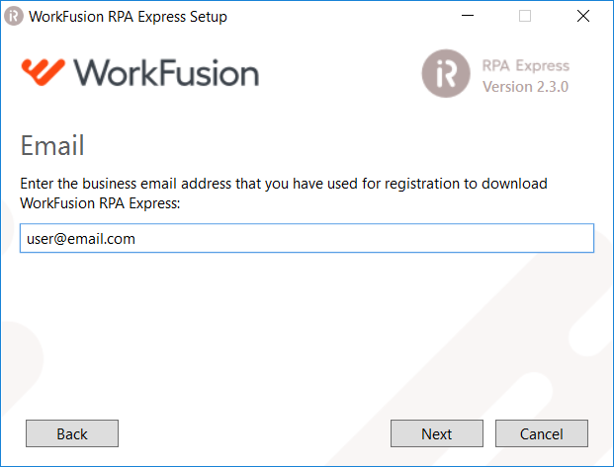

1. **Development Workstation (Free)**is selected by default. Click **Next**to proceed.

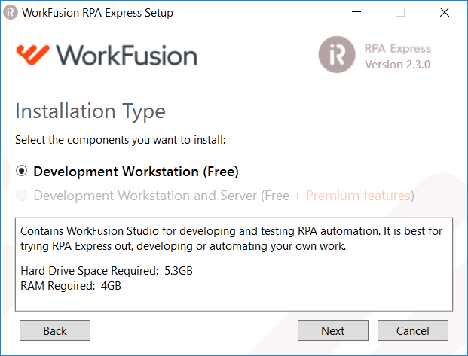

1. On the **RPA Express Administrator Credentials** screen, enter Administrator username and password that will be used to centrally manage your automations and click**Next**.
2. Pick **any username and password** at your choice, though observe the following requirements.

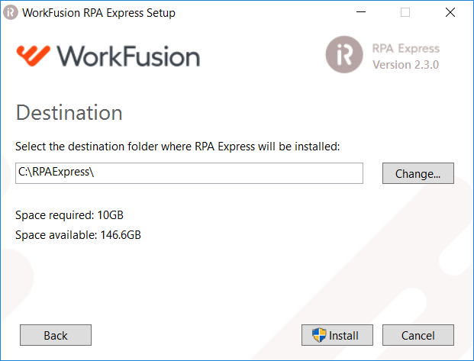– The username should be 5 to 20 characters long and contain lowercase Latin letters and digits. Special symbols are not allowed.

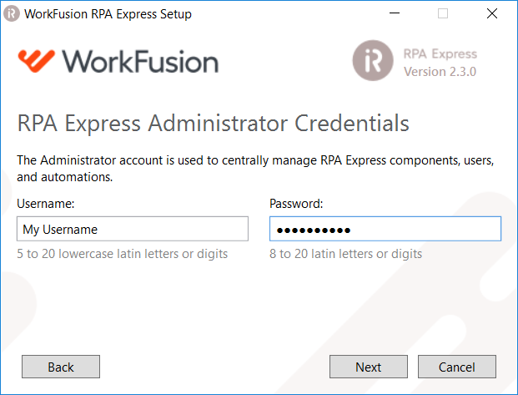– The password should be 8 to 20 characters long and contain Latin letters and digits. Special symbols are not allowed.

1. Set the destination folder for RPA Express installation and click **Install**.
2. Username and password are already registered with workfusion

Username: vinayak11

Password: 32Watts13579#

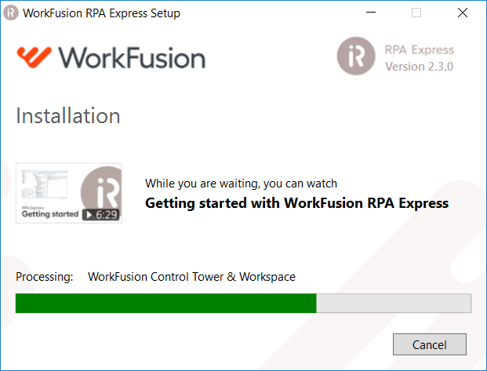

9. Wait until the installation is finished and click **Finish**. To launch RPA Express, click on the RPA Express icon on your desktop.

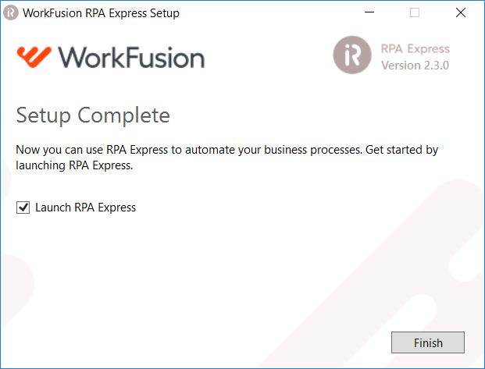

**Contributing:**

* So after launching the application user must be aware of Bot manager. User must start the bot manager before playing any of the recording. The other components may or may not be active as there is no role of them in our project.

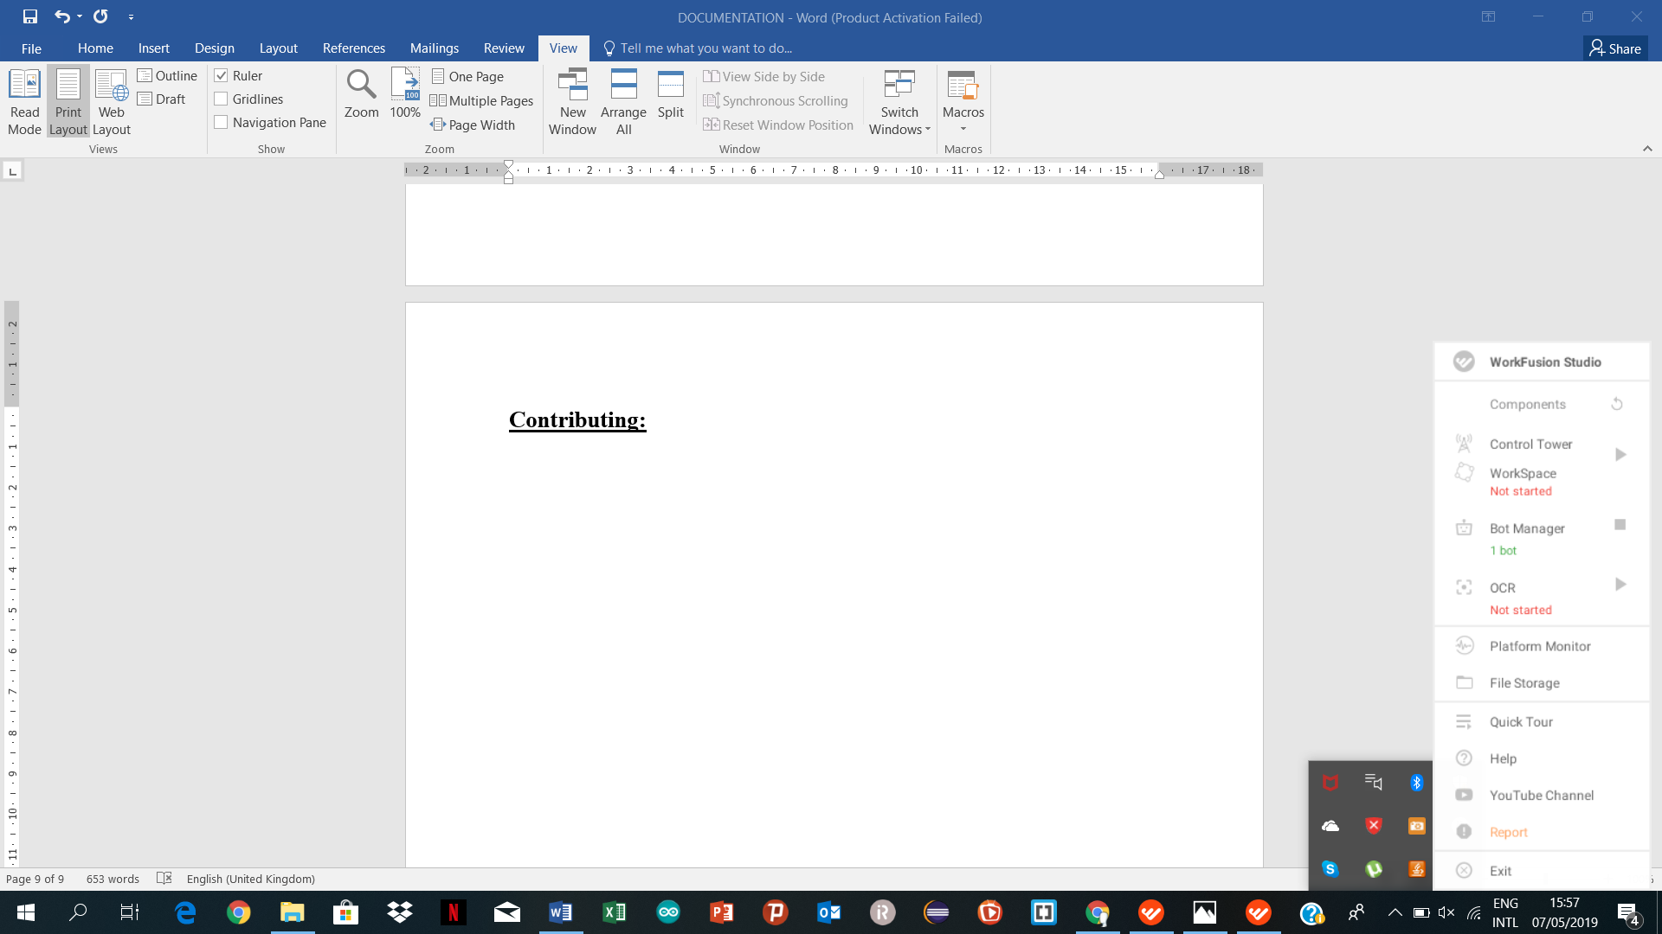

* User can create new recording or new file in RPA Recorder option in main menu. The file can be run by clicking on play recording option. Sometimes file may not work or throw an error “unable to connect bot”. In that case user must restart the bot manager.

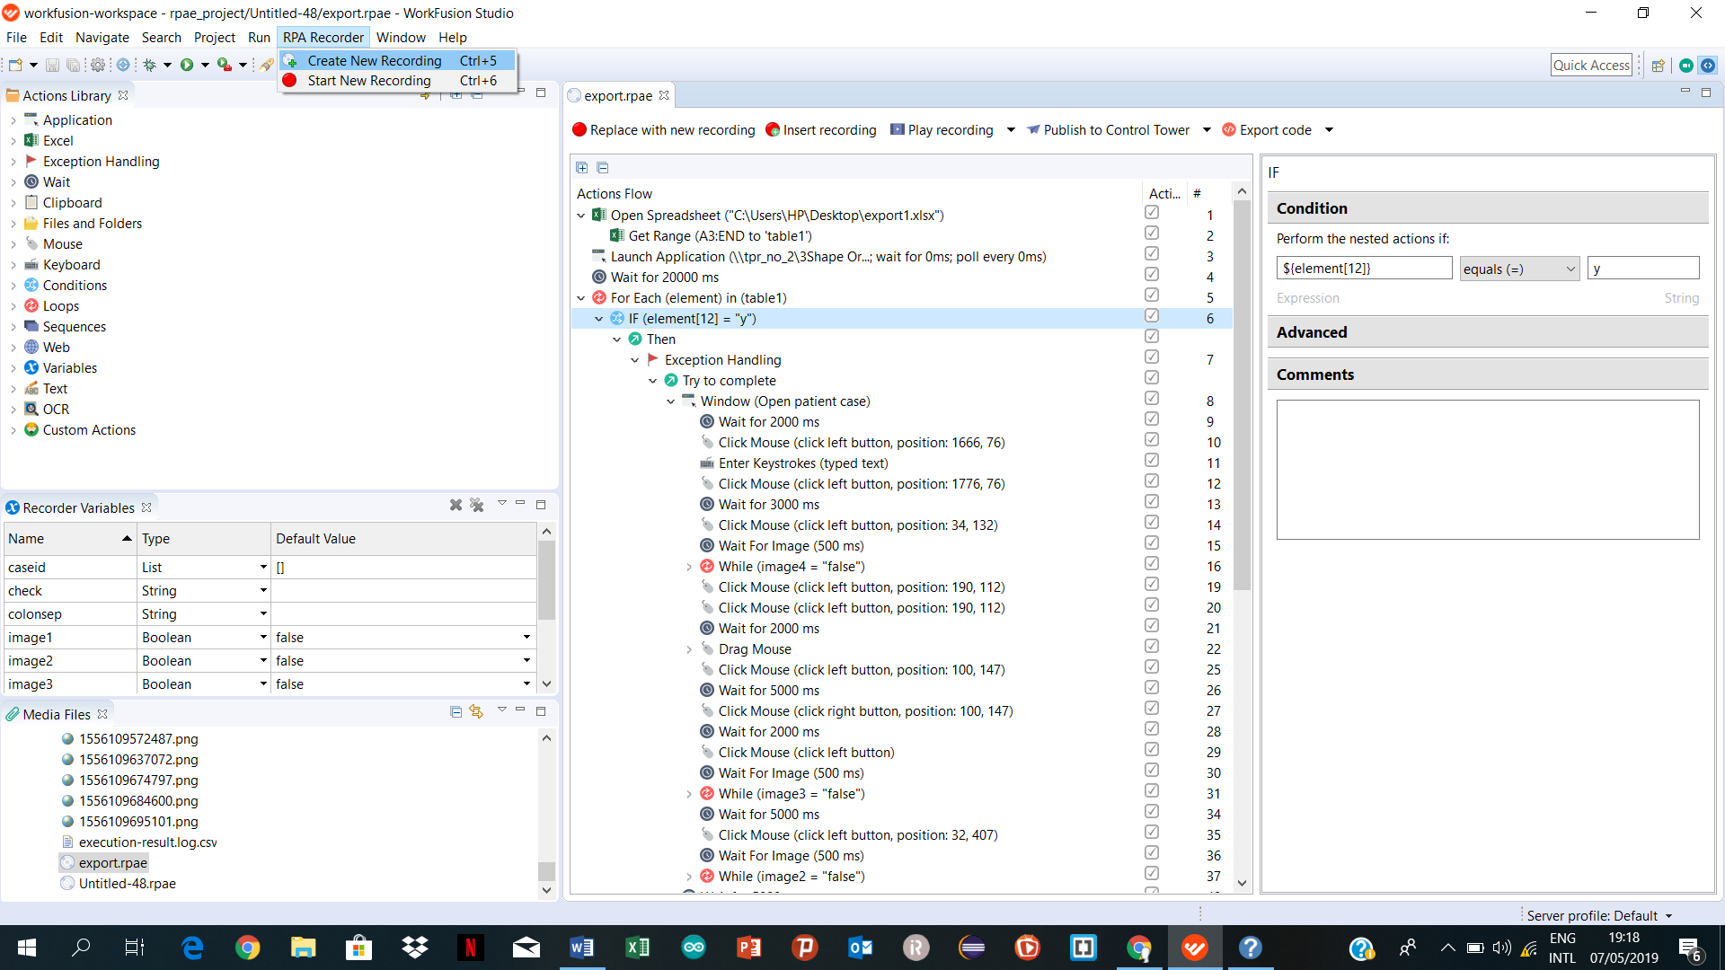

* User can perform certain action by writing various scripts from action library. Also user can declare certain variables according to need in the program. It supports many data types like Boolean, string, number etc. It is not necessary to initialise the variable with certain value.

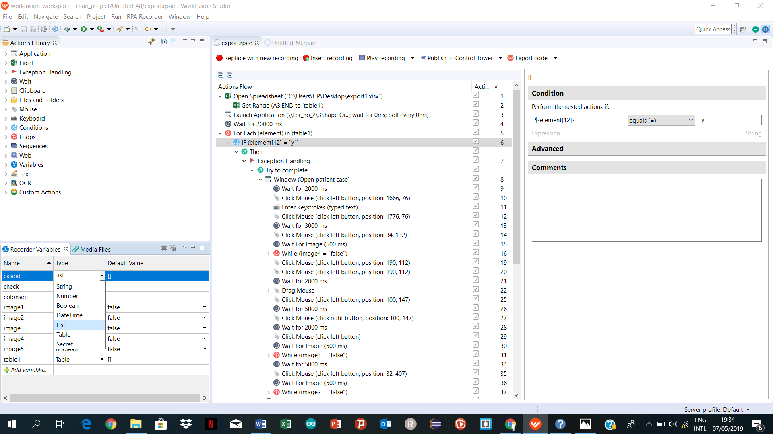

* Various actions are used in our projects from action library like application launch, mouse operations, excel operations and many more.
* **Get Range:**  It is used to get all the values from excel sheet. We can define from which cell we have import values from excel sheet. Get range must always be specified inside the excel spreadsheet. If we don’t specify the end cell, then it automatically import the whole excel sheet.

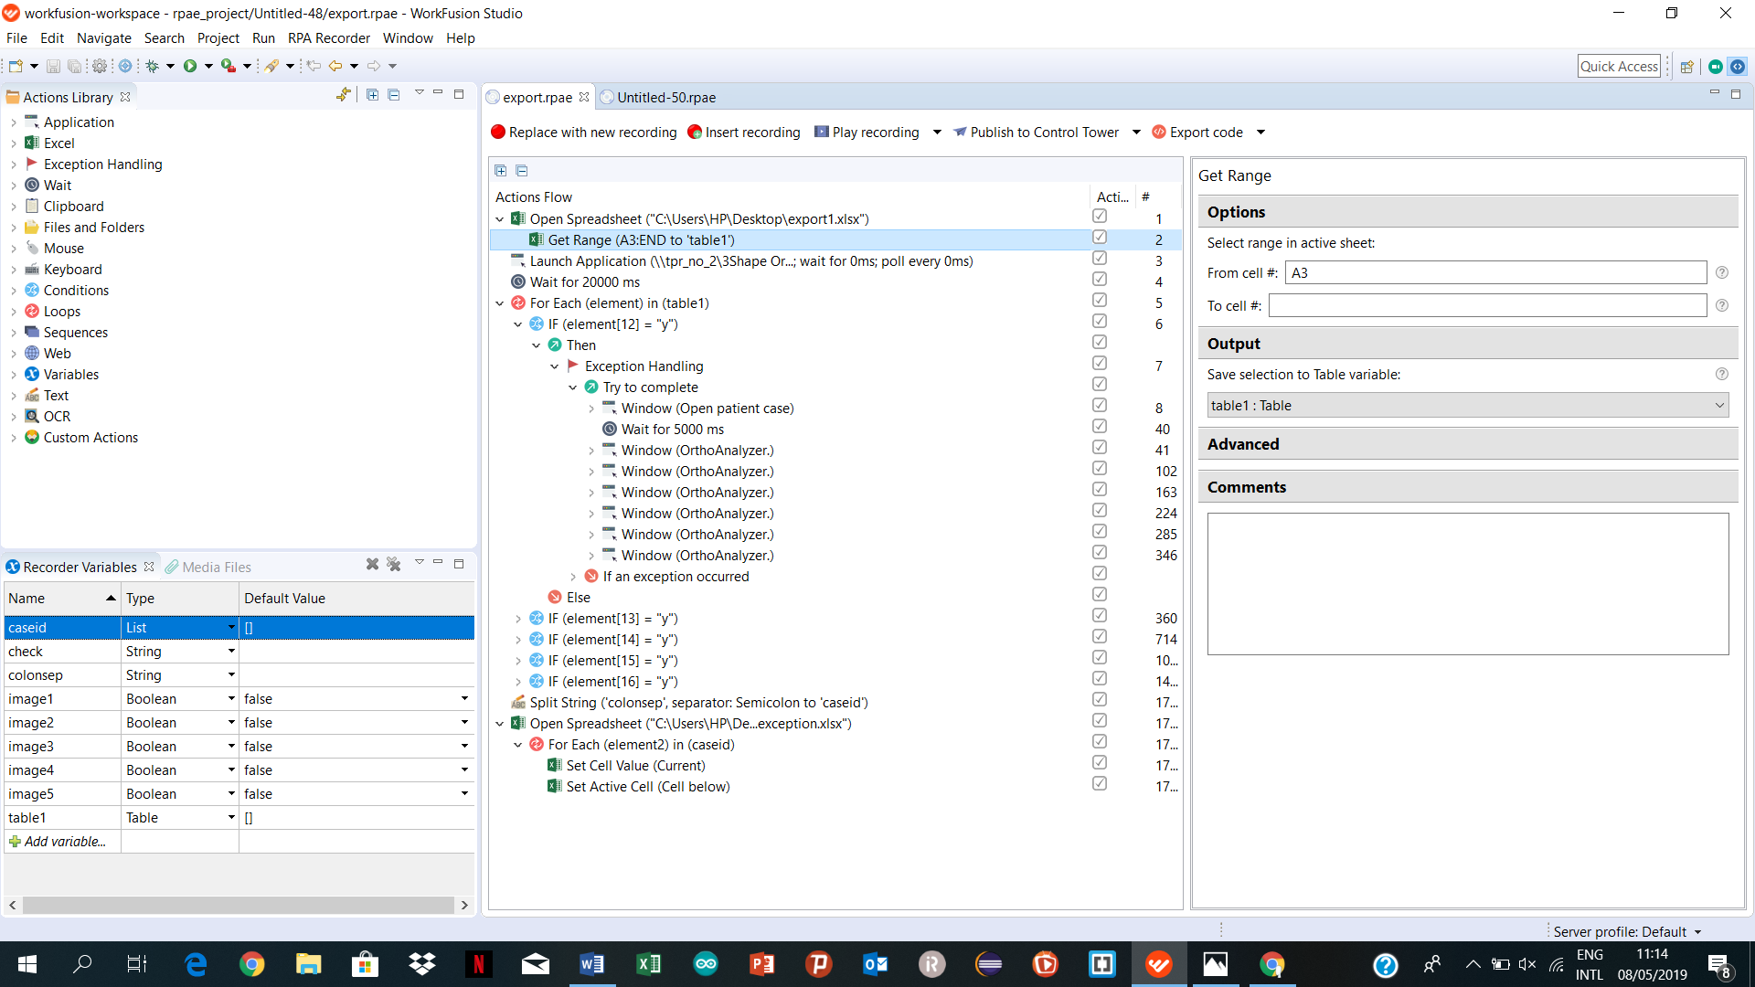

* **For each loop:** This action stores the values of excel in a list. The values can be stored in two ways either by rows or by columns. In our project we are iterating the loop by rows. For each loop perform every action written inside the loop on each row. Each row is stored as a list in variable. Here the variable is element.

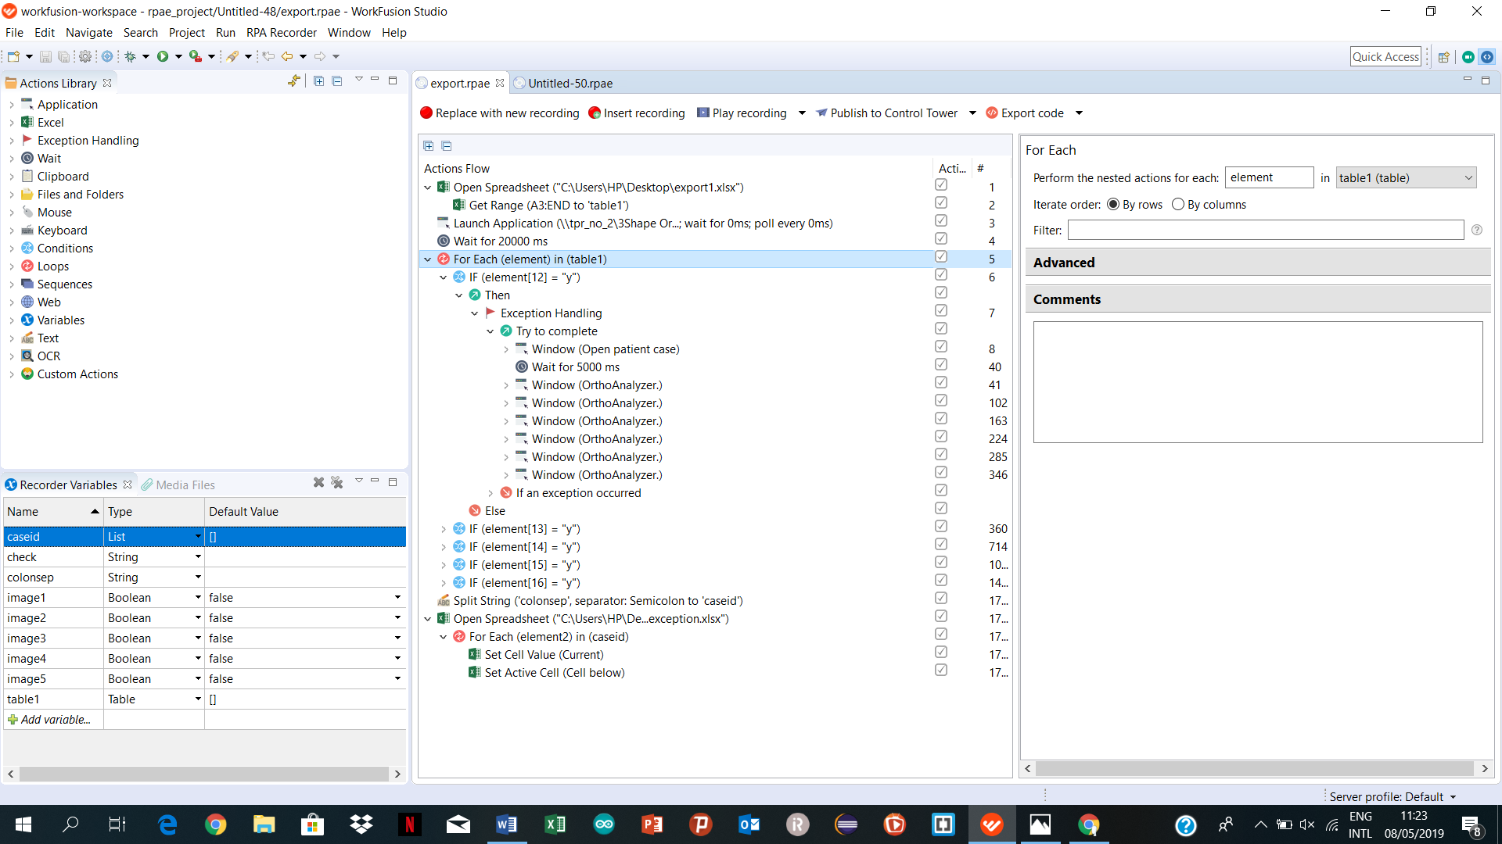

* **Exception Handling:** To get the error message in RPA Express, you can keep the code outside of exception handling and then, the software will through error message on its' own. Once you get the type of error (by running the bot once), you can put the solution in catch block by keeping the code inside exceptional handling feature.

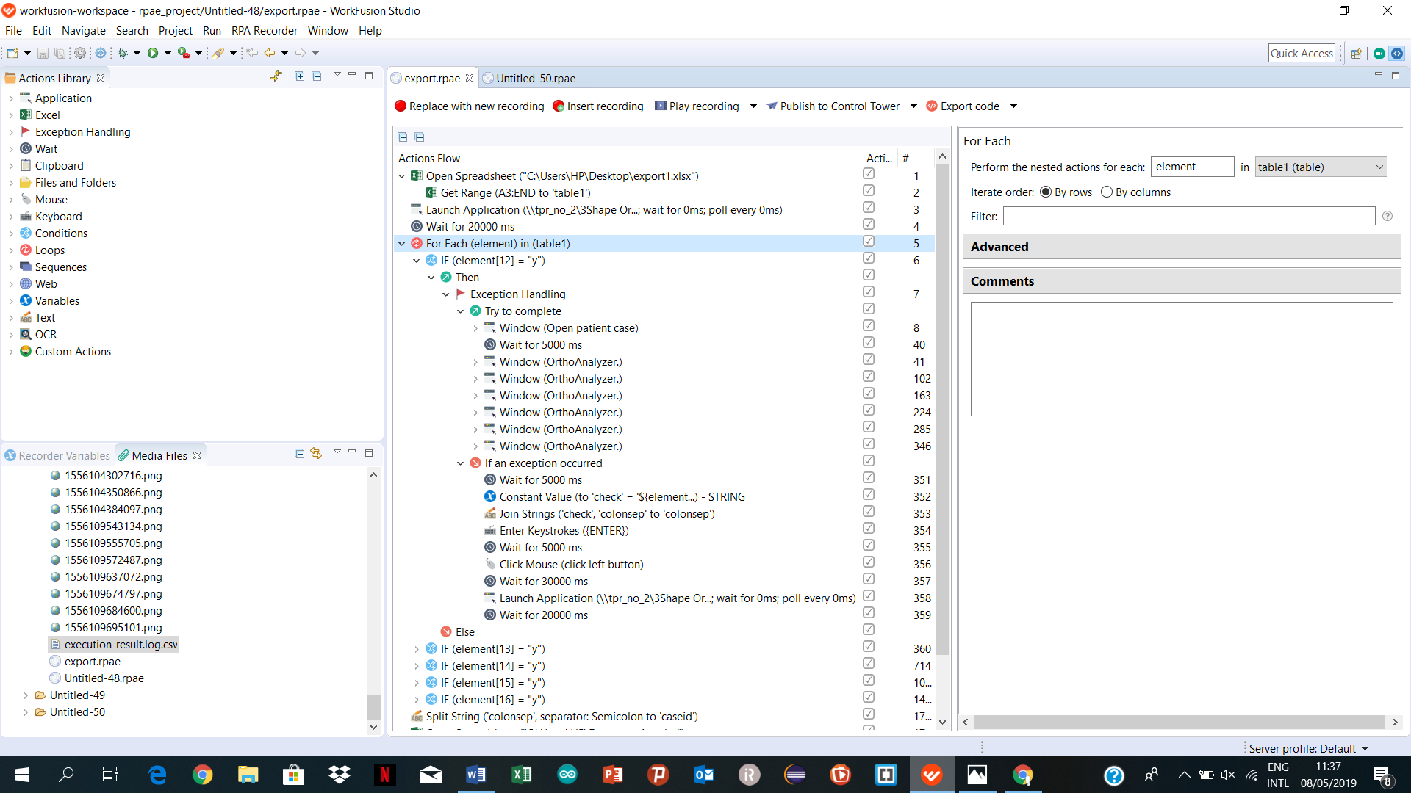

* **Windows:** This action help to bind all the action in one window. Many actions which are performing in one window are clubbed together so that action’s don’t get mixed up.



**Wait for image:** The action performs a search for a defined image on the current screen and puts the search result into a Boolean variable. The values are as follows.

* true – if the image was found on the current screen
* false – if the image was NOT found on the current screen

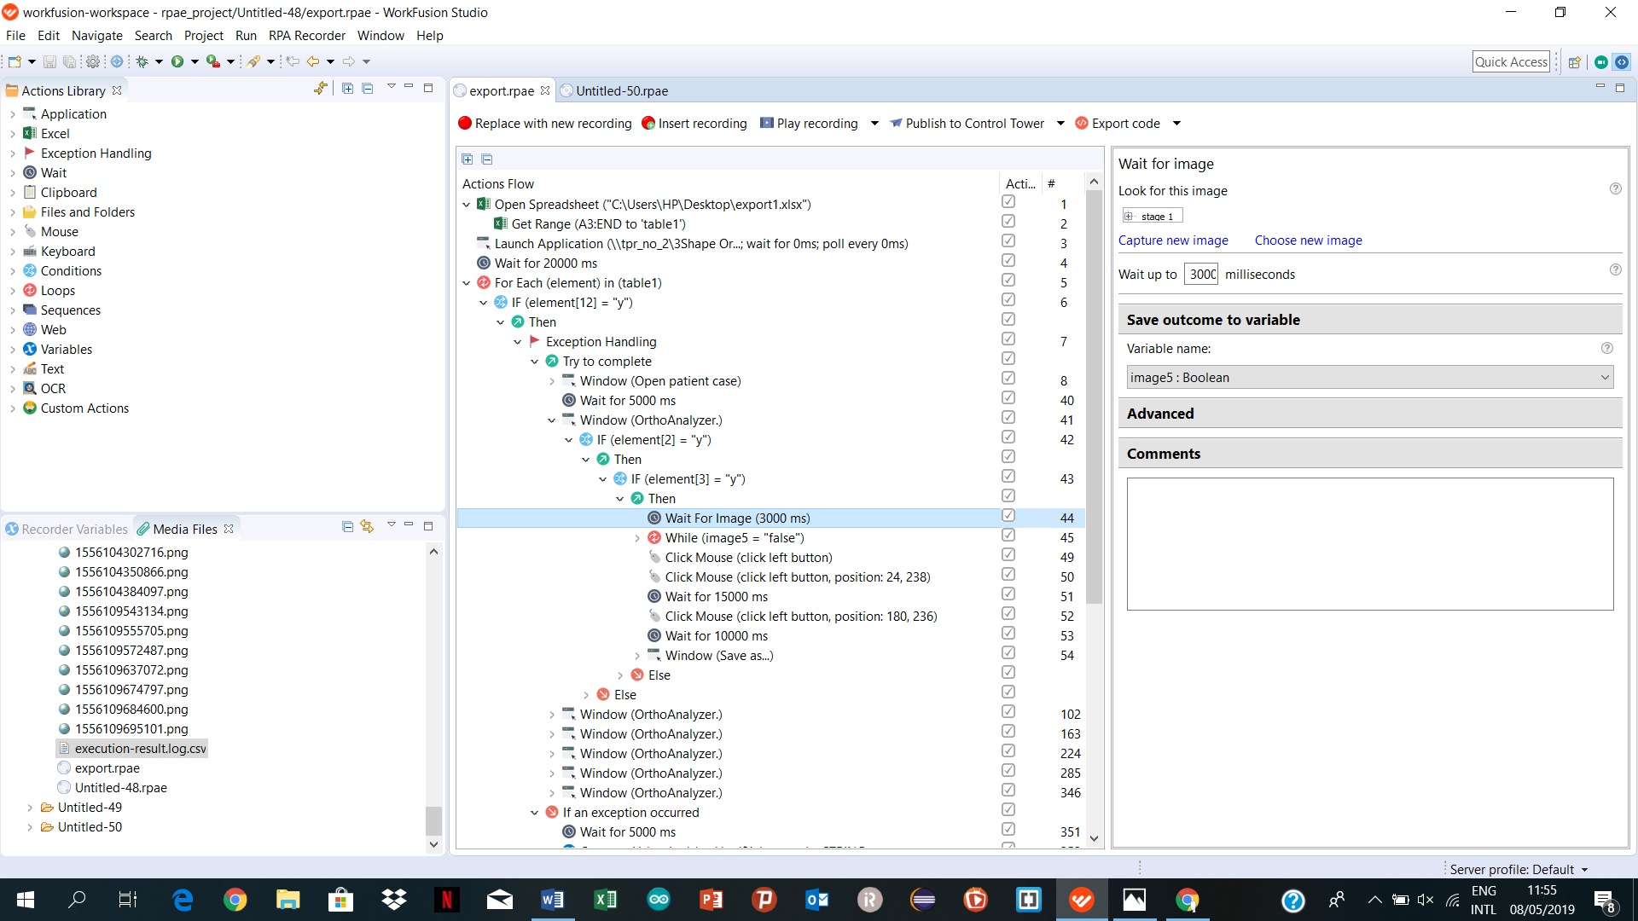

# Wait

The action pauses the bot execution for a specified amount of time, then

automatically resumes.

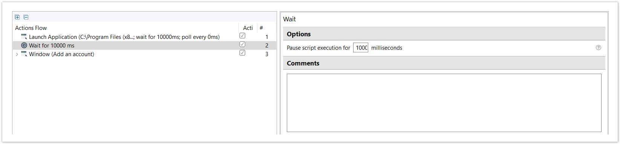

**MOUSE:** The Mouse action group is intended to interact with user interface using mouse. All the **Mouse** actions are automatically recorded when you manipulate your mouse during the [recording](https://kb.workfusion.com/display/RPAe/How+to+Use+RPA+Recorder#HowtoUseRPARecorder-Recordingproc) process.

You can add the Mouse [Click](https://kb.workfusion.com/pages/viewpage.action?pageId=15045750#Mouse-Mouseclick), [Move](https://kb.workfusion.com/pages/viewpage.action?pageId=15045750#Mouse-Mousemove), [Drag](https://kb.workfusion.com/pages/viewpage.action?pageId=15045750#Mouse-Mousedrag), or [Scroll](https://kb.workfusion.com/pages/viewpage.action?pageId=15045750#Mouse-Mousescroll) actions manually by dragging from [Actions Library](https://kb.workfusion.com/display/RPAe/Actions+Library) to Actions Flow.

| **Actions Library** | **Action Description** |
| --- | --- |
| https://kb.workfusion.com/download/attachments/15045617/ActionsLibraryWnd-Mouse.png?version=2&modificationDate=1541751378606&api=v2&effects=border-simple,blur-border | * [Mouse Action Location](https://kb.workfusion.com/display/RPAe/Mouse#Mouse-MouseActionLocation)   + [Window Control](https://kb.workfusion.com/display/RPAe/Mouse#Mouse-WindowControlWindowcontrol)   + [Image](https://kb.workfusion.com/display/RPAe/Mouse#Mouse-ImageImage)   + [Position](https://kb.workfusion.com/display/RPAe/Mouse#Mouse-PositionPosition)   + [Web Element](https://kb.workfusion.com/display/RPAe/Mouse#Mouse-WebElementWebelement) * [Mouse Actions](https://kb.workfusion.com/display/RPAe/Mouse#Mouse-MouseActions)   + [Click Mouse](https://kb.workfusion.com/display/RPAe/Mouse#Mouse-MouseclickClickMouse)     - [Find Element by Text](https://kb.workfusion.com/display/RPAe/Mouse#Mouse-FindElementbyText)     - [Find Element by XPath](https://kb.workfusion.com/display/RPAe/Mouse#Mouse-MouseClickXPathFindElementbyXPath)     - [Find Element Example](https://kb.workfusion.com/display/RPAe/Mouse#Mouse-FindElementExample)   + [Move Mouse](https://kb.workfusion.com/display/RPAe/Mouse#Mouse-MousemoveMoveMouse)   + [Drag Mouse](https://kb.workfusion.com/display/RPAe/Mouse#Mouse-MousedragDragMouse)   + [Scroll Mouse](https://kb.workfusion.com/display/RPAe/Mouse#Mouse-MousescrollScrollMouse) |

**Keyboard:** The Keyboard action group is intended for entering text and typing key combinations using keyboard. The **Enter Keystrokes** action is automatically recorded when you type something during recording process.

You can add the **Enter Keystrokes** actions manually when editing a recording by dragging it from Actions Library to Actions Flow.

There are three ways of using the **Enter Keystrokes** action.

* [Key combination](https://kb.workfusion.com/display/RPAe/Keyboard#Keyboard-Combinat) (e.g., 'CTRL + HOME')
* [Type](https://kb.workfusion.com/display/RPAe/Keyboard#Keyboard-Type) text (e.g., 'Some input text string that cannot be changed at run-time')
* Text from [variable](https://kb.workfusion.com/display/RPAe/Keyboard#Keyboard-Variable) (e.g., ${current_State}– dynamical value)

| **Actions Library** | **Action Description** |
| --- | --- |
| **Actions Library** | **Action Description** |
| https://kb.workfusion.com/download/attachments/15045632/Keyboard-Actions.png?version=1&modificationDate=1541752439572&api=v2&effects=border-simple,blur-border | * [Key Combination](https://kb.workfusion.com/display/RPAe/Keyboard#Keyboard-KeyCombinationCombination) * [Type Text](https://kb.workfusion.com/display/RPAe/Keyboard#Keyboard-TypeTextType) * [Text from Variable](https://kb.workfusion.com/display/RPAe/Keyboard#Keyboard-TextfromVariableVariable) |

* **Variables:**

Using **Variables** from Actions Library, you can assign the following values to Recorder variables:

* Random value
* Constant value
* Expression result
* Number format
* Date format

| **Actions Library** | **Actions Description** |
| --- | --- |
| https://kb.workfusion.com/download/attachments/15045810/ActionsLibraryWnd-Variables.png?version=2&modificationDate=1541761877065&api=v2&effects=border-simple,blur-border | * [How to Use Variables](https://kb.workfusion.com/display/RPAe/Variables#Variables-HowtoUseVariables) * [Random Value](https://kb.workfusion.com/display/RPAe/Variables#Variables-RandomValueRandomValue) * [Constant Value](https://kb.workfusion.com/display/RPAe/Variables#Variables-ConstantValueConstantValue) * [Expression Value](https://kb.workfusion.com/display/RPAe/Variables#Variables-ExpressionValueExpressionValue) * [Number Format](https://kb.workfusion.com/display/RPAe/Variables#Variables-NumberFormatNumberFormat) * [Date Format](https://kb.workfusion.com/display/RPAe/Variables#Variables-DateFormatDateFormat) |

# Constant Value

The **Constant Value** action is used to assign a constant value to the Recorder Variable. Specify the following properties.

* **Variable** – a Recorder Variable which gets the value from **Constant Value**. The value type is the same as the type of the Recorder Variable which the Action Variable is bound to.
* **Value** – the value to be assigned. The value corresponds to the type of the Recorder Variable where the value is set to.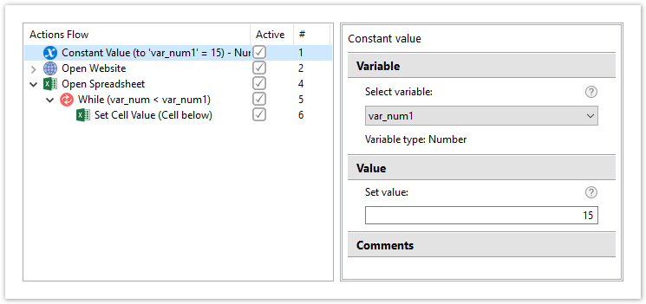

# Expression Value

The **Expression Value** action has three functions, depending on the type of the assigned variable:

* with [a variable of Number type](https://kb.workfusion.com/display/RPAe/Variables#Variables-NumberVariable), it computes a value from operations with a number of the Recorder variables
* with [a variable of List type](https://kb.workfusion.com/display/RPAe/Variables#Variables-ListVariable), it appends a text or content from another list to the list, or gets the list size and saves it to a numeric variable
* with [a variable of Table type](https://kb.workfusion.com/display/RPAe/Variables#Variables-TableVariable), it appends a content of a list to the table either as a row or a column, or gets the number of table rows or columns and saves the size to the respective numeric variable

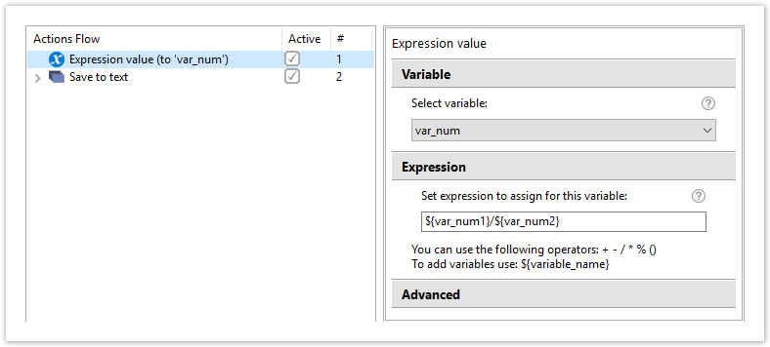

# Number Format

The **Number Format** action enables conversions of number values to/from string values. Select one of the available options.

* **Reformat string**  – extracts a number value in a predefined format from a string variable, applies another format to the extracted number value, and saves the result to a string variable
* **Convert number to string** – converts a number variable value to a string value using a predefined format and saves the result to a string variable
* **Convert string to number** – converts a string variable value to a number value using a predefined format and saves the result to a number variable

**Reformat String** is used to change the format of the number value containing in a string.

